"Day 4 - Dynamic Frontend Components –[NIKE]"

The Code snippets for key components (e.g., ProductCard, ProductList, SearchBar).

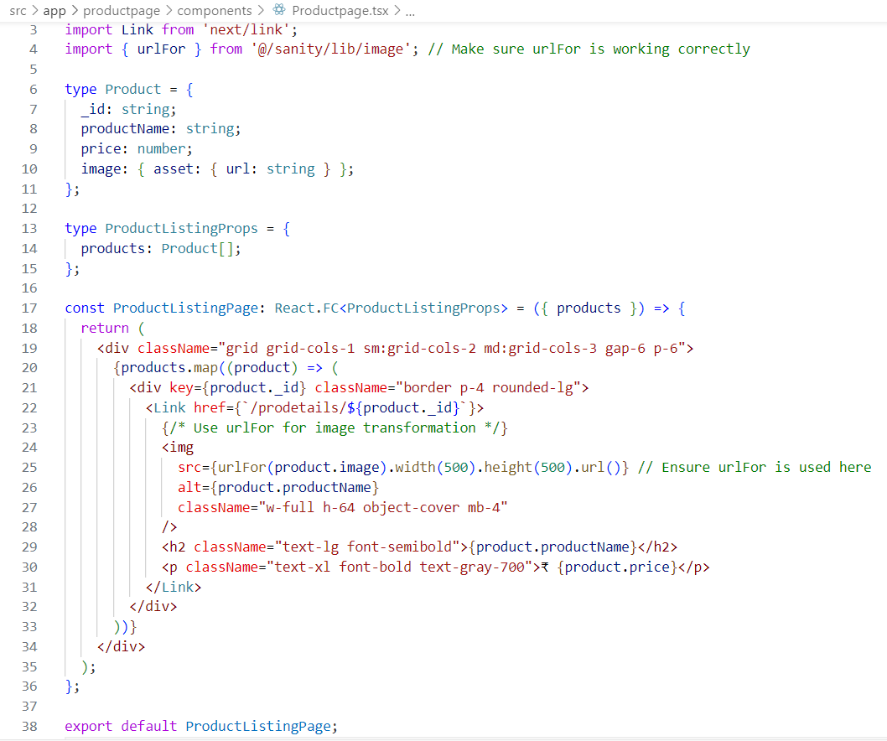

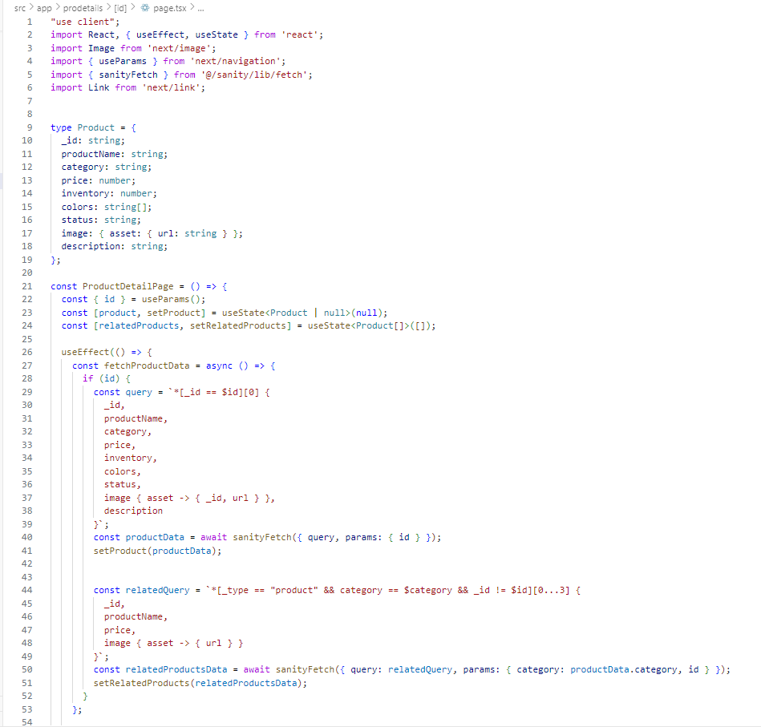

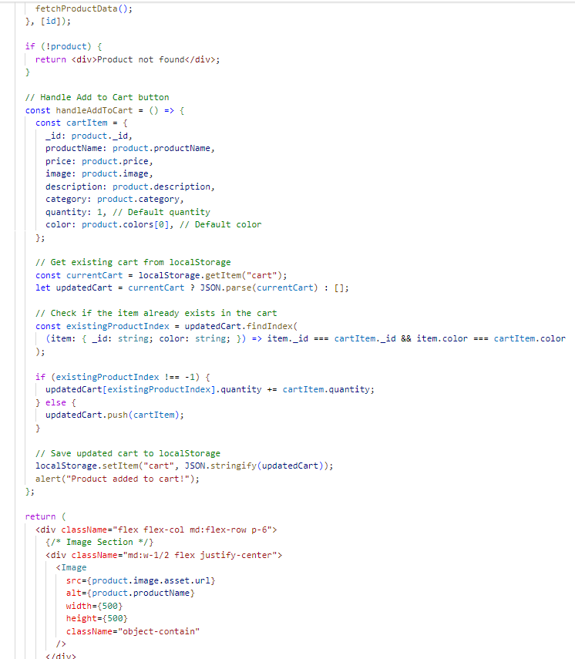

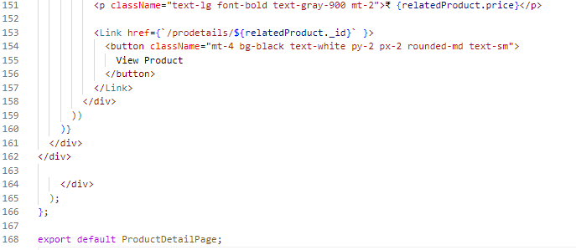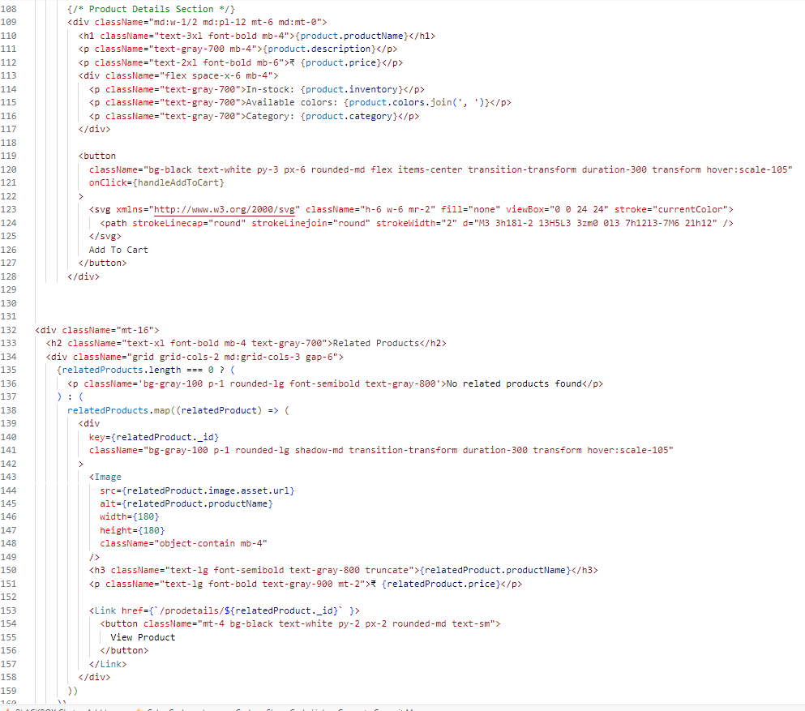

**Technical Report on E-commerce Platform Development**

**Steps Taken to Build and Integrate Components**

The e-commerce platform was developed using Next.js with a focus on dynamic data fetching from a Sanity backend. I started by creating a product listing page, which dynamically displays products based on data from the backend. A dynamic product detail page was then implemented to show detailed information, including images, price, inventory, and product description. The cart, billing, and checkout features were also integrated, enabling a functional e-commerce experience.

**Challenges Faced and Solutions Implemented**

One of the main challenges was implementing a search feature. Despite multiple attempts, I could not get the search functionality working within the time frame, but this will be addressed in the future. The category filter was another hurdle, but I successfully integrated a category filter into the sidebar to allow users to filter products by their chosen categories.

**Best Practices Followed**

During development, I adhered to best practices such as clean code, reusable components, and responsive design to ensure the application is scalable and user-friendly. Additionally, I ensured the platform is mobile-friendly, providing a seamless experience across devices. The use of dynamic data and related product features enhances the user experience by keeping content up-to-date and engaging.

